

WORKING EQUITATION AUSTRALASIA
For the First Time in the Tweed!

STYLE PRECISION SPEED
DRESSAGE WITH PURPOSE
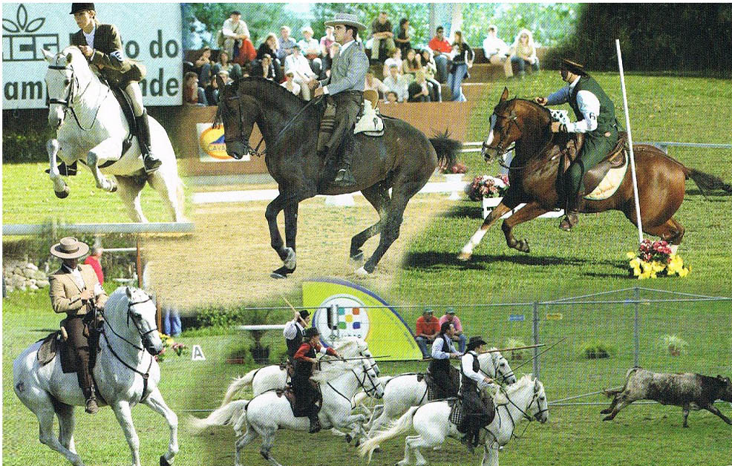
A FUN WAY TO TRAIN SERIOUSLY
Working Equitation Clinic
with International Working Equitation trainer Gill Kennerley

Gill helped introduce Working Equitation to the UK and, having recently moved to Australia, is doing the same here.
(check out www.workingequitationaustralia.com and/or do a youtube search).

The plan is to establish Working Equitation in the Tweed Valley.

Dates: Saturday 24th & Sunday 25 August 2013 (9 am – 4 pm both days)
Venue: Omaru Classical Riding Centre
707 Limpinwood Road, Limpinwood (near Tyalgum)
Cost: $300 for the 2 days (only 10 places available)
$50 per day for spectators (spectators participate in the theory sessions too)

Working equitation is an equestrian discipline well established as a recognized sport in Portugal, Spain, France, Italy, Belgium, Great Britain, Mexico, Brazil and Sweden. There are different levels of competition from novice to advanced, open to all riders and all breeds of horses. The competition is designed to test horse and rider through a range of activities combining flat work (Dressage) movements and obstacle courses and aims to promote good horsemanship. It is great fun for horse and rider and spectators also enjoy this exciting discipline.
This clip is of the world's leading Working Equitation rider: http://www.youtube.com/watch?v=XZ8d9ByD5L4&feature=fvwp

For more info and to book in, please contact:
Dianne Baxter on 02 66792238 or email ddbaxter@bigpond.com

