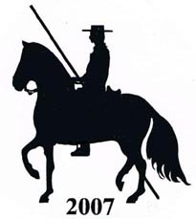

WORKING EQUITATION; MARK SHEET
OBSTACLE TEST, marks out of 10

Entry……………….……………..…Rider………………………………………….……..Horse……………………………………………Date……...…….
Judges Comments

1

2

3

4

5

6

7

8

9

10

11

12

13

14

15

General Aspects,
Marks out of 5

1. Attention & Response……
2. Accuracy of test…………..
3. Continuity & Control…….
4. Harmony between horse
& rider…………………….
5. Acceptance of contact……
6. Ridden in 1 hand only……
7. Ridden in walk & canter…
8. Turn out,………………….

Final Total

1. Obstacles . 150………
2. General Aspects. 45………
3. Bonus……………………..
4. Penalties…………………..
5. Final Mark………………...

Judges Signature………………………………….........

